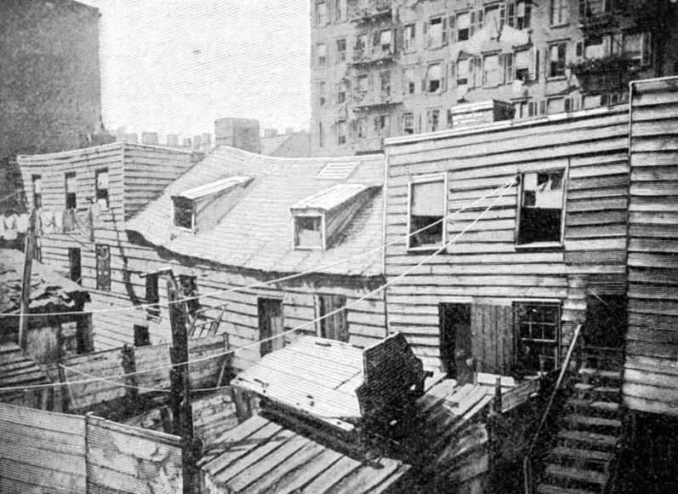
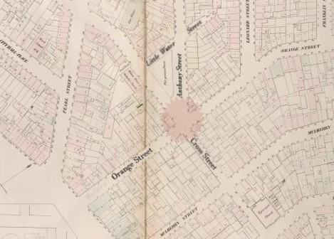

Paradise Square—Paradise Lost: an overgrown park.
Five Points—Demonic Pentagram w/ hangman guillotine
The map’s contrast is the intersection of District (market, streets but close quarters) and Chinatown (close-quarters, multi-level fighting).
Many windows open to brick walls, and many alleys lead nowhere
Jump spots and flanking routes are emphasized.
Many routes go through or over buildings.
Modern day rendition of an old environment.
Pipes will be odd to add… power lines? YES! Huge bundle cables.
Everything else, covered as a fire escape.

